INTRODUCTION

In today’s digitally connected world, the concept of IoT (Internet of Things) has revolutionized the way we interact with our environment, especially within our homes. The rise of smart technologies has transformed traditional living spaces into intelligent, responsive, and automated ecosystems. At the core of this transformation lies the IoT-enabled smart room—a concept that is redefining modern living by offering unparalleled convenience, energy efficiency, and personalized comfort. These interconnected devices, sensors, and systems create a responsive environment that adapts to the needs and preferences of its users, ultimately enhancing daily life and redefining the idea of home automation.

Motivation

The motivation behind creating an IoT smart room stems from the need for increased convenience, energy efficiency, security, and personalized living spaces in today's fast-paced world. Traditional living environments lack the ability to adapt to the needs of the user, requiring manual intervention for simple tasks like adjusting the thermostat, lighting, or security systems. With the integration of IoT technologies, smart rooms offer automation and personalization that respond to users’ routines, preferences, and environmental conditions, reducing the need for constant manual adjustments. Moreover, as the demand for sustainable living solutions grows, smart rooms provide a way to optimize energy consumption and minimize wastage while maintaining comfort.

Objective

To create an interconnected, automated living environment using IoT technologies.

Automate everyday tasks like lighting, temperature control, and security management.

Enable users to personalize their smart rooms according to their needs and preferences.

Integrate devices like motion sensors, smart thermostats, lighting systems, and entertainment devices for a seamless experience.

Promote sustainability by optimizing energy use and reducing household carbon footprints.

Summary

In conclusion, IoT smart rooms represent the future of modern living. By blending technology with daily functionality, they offer an unparalleled combination of comfort, efficiency, and sustainability. From intelligent lighting and climate control to enhanced security and entertainment, smart rooms are transforming traditional living spaces into dynamic, responsive environments. While challenges like data privacy and device compatibility remain, the long-term benefits of energy savings, security, and convenience make IoT smart rooms a viable solution for the future of home automation. As IoT technologies continue to evolve, smart rooms are set to become an integral part of everyday life, shaping the future of intelligent homes.

ABOUT PROJECT

Project Introduction

Home Fusion is a comprehensive IoT-based home automation project designed to transform conventional living spaces into smart, interconnected environments. The primary goal of the project is to create an ecosystem where users can easily control, monitor, and automate various aspects of their home, such as lighting, temperature, security, and energy usage, using a single platform. This system is built to be intuitive, scalable, and customizable to meet the needs of a diverse range of users, from tech enthusiasts to those new to smart home technology.

At its core, Home Fusion connects a wide array of IoT devices, such as smart bulbs, thermostats, cameras, and motion sensors, to a central server that acts as the brain of the system. Through a mobile or web application, users can monitor their home in real-time, adjust settings, and receive notifications about important events. The system also allows for automation of tasks such as scheduling lights to turn on or off, adjusting the temperature based on occupancy, and sending security alerts when motion is detected.

What sets Home Fusion apart is its focus on user experience and energy efficiency. The platform is designed to offer not only convenience but also intelligent insights into how users can optimize their energy consumption and reduce costs. By tracking device usage and providing analytics, Home Fusion enables users to make informed decisions about their home's energy management, ensuring a more sustainable and eco-friendly living environment.

Additionally, Home Fusion offers integration with popular voice assistants such as Amazon Alexa, Google Assistant, and Apple Siri, allowing users to control their home systems with simple voice commands. The system also supports remote access, meaning users can control their home even when they are not physically present, giving them complete flexibility and control over their environment.

Ultimately, Home Fusion is about making everyday life simpler, safer, and smarter. Whether you're at home or away, the platform ensures that your home is working for you—adjusting to your needs and preferences to create an optimal living environment. Through seamless integration, automation, and real-time monitoring, Home Fusion is the future of home living, offering users a smart home experience that fits their lifestyle, enhances their comfort, and improves their well-being.

Technology Stack

To build Home Fusion, we are leveraging a combination of modern technologies to ensure smooth integration of IoT devices, real-time data management, and a user-friendly interface. The chosen technologies focus on scalability, security, and ease of use, offering a seamless experience for users as they interact with and manage their smart home systems.

Microcontroller: ESP32 Devkit V1

The heart of the IoT devices in Home Fusion is the ESP32 Devkit V1. This microcontroller is chosen for its powerful processing capabilities and built-in Wi-Fi and Bluetooth support, which are essential for the smooth operation of smart devices within a home. The ESP32 allows for easy integration with the central server via Wi-Fi, enabling real-time communication with various sensors, lights, thermostats, cameras, and more. This makes it an ideal choice for managing a wide range of devices with minimal power consumption.

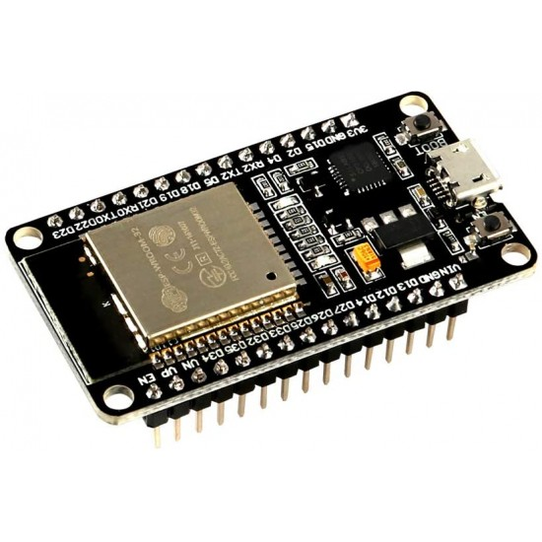

The ESP32 is capable of collecting data from various devices, such as motion sensors, temperature sensors, and cameras, and transmitting it to the central server. The microcontroller also processes commands from the central server, allowing users to control devices remotely.

ReactJS and Redux



For the front-end application, we are using ReactJS, a widely used JavaScript library for building user interfaces. React allows us to create dynamic, responsive, and modular components that are easy to manage and update. By leveraging the component-based architecture of React, the app can be easily extended with new features in the future.

Redux is used for state management in the application, helping maintain consistency across different components of the app. It ensures that user actions, such as turning lights on or adjusting the temperature, are reflected in real time across the entire app. With Redux, we can synchronize the app's state and manage the flow of data, making the system more efficient and responsive.

Firebase and Firestore



For backend infrastructure, Firebase is used to handle critical aspects of the system, such as real-time data syncing, user authentication, and cloud storage. Firebase provides a robust and scalable solution for building cloud-based applications. Firestore, a NoSQL database from Firebase, is used to store and retrieve data such as user settings, device states, and logs. Firestore’s real-time syncing capabilities ensure that any changes made in the system, such as a user turning off a light, are instantly reflected across all connected devices.

Firestore is also integral in updating and maintaining user data, such as preferences for scheduling and automation rules, securely in the cloud. This enables users to have their settings and configurations synchronized across multiple devices, ensuring an uninterrupted user experience.

Security and Data Privacy

Ensuring the security and privacy of user data is a top priority in the Home Fusion project. All data transmitted between devices, the central server, and the mobile/web application is encrypted using industry-standard encryption protocols. Firebase provides secure authentication for users, ensuring that only authorized individuals can access and control their smart devices.

To further enhance security, sensitive data, including user credentials and device settings, is stored securely in Firestore with strict access controls and permission management. These measures help prevent unauthorized access and ensure that user data remains private and protected.

Voice Assistant Integration

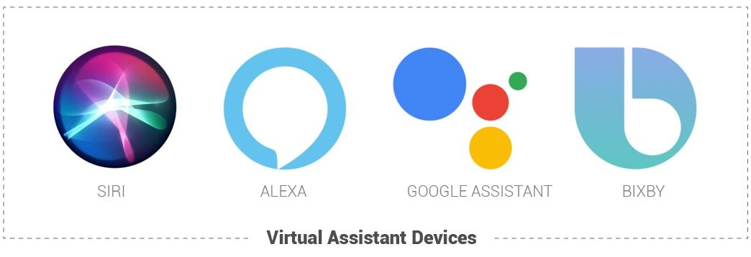

Home Fusion will also integrate with popular voice assistants such as Amazon Alexa, Google Assistant, and Apple Siri, enabling users to control their smart devices with voice commands. By leveraging these voice-controlled platforms, Home Fusion makes it even easier for users to interact with their homes—whether it’s adjusting the thermostat, turning on the lights, or checking the security cameras, all with simple voice instructions.

Voice integration adds another layer of convenience, making the system even more intuitive and accessible, especially for users who prefer hands-free control or have mobility constraints.

Challenges and Solutions

Developing a smart home solution comes with its own set of challenges. Some of the key challenges faced during the development of Home Fusion include:

Interoperability: Different devices often come with different communication protocols and standards. To address this, we standardized communication through the use of MQTT and ensured that all IoT devices could connect seamlessly.

Security: As with any IoT-based solution, ensuring data privacy and security is critical. We implemented end-to-end encryption for data transmission and ensured that user credentials were securely managed through Firebase Authentication.

Scalability: As the number of devices and users grows, ensuring that the system can scale without performance degradation is essential. We leveraged cloud infrastructure to ensure scalability and reliability as the project expands.

Usability: Designing an intuitive user interface that is easy to navigate and use is essential. We focused on simplicity and ease of use, ensuring that even non-technical users could operate the system effectively.

Future Scope

The Home Fusion project lays the foundation for a highly advanced smart home ecosystem. In the future, we aim to expand the capabilities of Home Fusion by:

Integrating More Devices: Expanding the range of devices that can be controlled through the platform, such as smart refrigerators, washing machines, and entertainment systems.

AI and Machine Learning: Incorporating AI algorithms to learn user behavior and preferences to automate home systems more intelligently and effectively.

Advanced Security Features: Enhancing security features with facial recognition, biometric access control, and AI-based threat detection.

Integration with Other Smart Home Platforms: Providing users with the ability to integrate their Home Fusion system with other popular smart home platforms for broader compatibility and ease of use.